Contents

**Switch in between graphical.target and multiuser.target** 1

**Switch to rescue.target or emergency.target** 1

# **Switch in between graphical.target and multiuser.target**

Say, current target is graphical.target

* Check current target,

Command: systemctl get-default

* To switch target to multiuser target temporarily,

Command: systemctl isolate multi-user.target

After reboot, again current target will be appeared.

* To make changes after reboot,

Command: systemctl set-default multi-user.target

* Verify with reboot

# **Switch to rescue.target or emergency.target**

* reboot
* Press any key

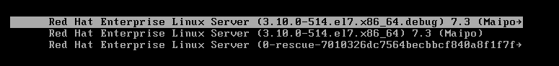

* e to edit
* Identify line containing “vmlinuz” or “linux16”. Go to the end of line (END key) and type following line:



To rescue target, systemd.unit=rescue.target

To emergency target, systemd.unit=emergency.target

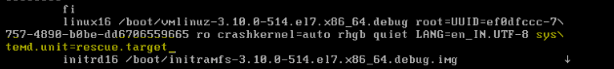



* Press Ctrl+x to boot.
* Type root password to perform tasks in rescue mode.
* Ctrl-d or reboot